# Assignment Portfolio

## Homework 1

**Excercise 1**

1. What regular expressions do you use to extract all the dates in this blurb: <http://bit.ly/regexexercise2> and to put them into the following format YYYY-MM-DD ?
2. \d{1,2}.?\d{1,2}..?\d{1,4}

**Excercise 2**

1. Write a regular expression to convert the stopwordlist (list of most frequent Danish words) from Voyant in <http://bit.ly/regexexercise3> into a neat stopword list for R (which comprises "words" separated by commas, such as <http://bit.ly/regexexercise4>). Then take the stopwordlist from R <http://bit.ly/regexexercise4> and convert it into a Voyant list (words on separate line without interpunction)

Regular expression  
(\S+\b)(\n)

Substitution  
"$1",

**Exercise 3**

Words in an essay can never accurately capture the ideal spreadsheet. However the ideal spreadsheet should be easy to work with, draw its information from good sources and have good human readability, meaning that it should should be obvious to the reader the different columns and rows mean. Furthermore it is important to avoid special characters, so they don’t interfere with the programming language used to read the dataset. Which special characters are okay to use will differ depending on the program. Fx in R an underscore is unlikely to interfere. One should also only have one value pr cell.

**Exercise 4**

[Dd]i\*s\s[Mm]anibus|[Dd][Mm]|[Dd][Mm][Ss]|[Dd]i\*s\s[Mm]anibus\sSacrum

24062 matches

## Homework 3

**Exercise 1**

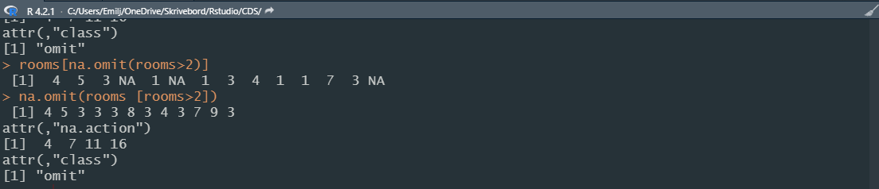

Code:  
rooms <- c(1, 2, 4, 5, 1, 3, 1, NA, 3, 1, 3, 2, 1, NA, 1, 8, 3, 1, 4, NA, 1, 3, 1, 2, 1, 7, 1, 9, 3, NA)

na.omit(rooms [rooms>2])

**Exercise 2**

code: class(rooms)

numeric

**Exercise 3**

Interviews <- read.csv("data/SAFI\_clean.csv")



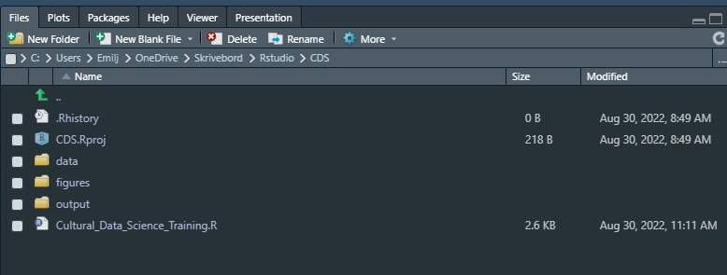

<https://github.com/Digital-Methods-HASS/AU633260_Emil_B_Jacobsen>

## Homework 4

**DESCRIPTION**

For this Visualisation assignment, you engage in **one of the two** tasks and submit an rmarkdown and html document (ie, a knitted result) that collects the results of both tasks:

Choose **one** of the two options below and follow the instructions in rmarkdowns. These have slightly different content depending on what you wish to practice, whether facets in ggplot or animation. For the latter, pay attention to the prerequisites R specifies for your system:

**1)** Historical homicide trends across Western Europe (ggplot practice) <https://github.com/Digital-Methods-HASS/HomicideHistory>

OR

**2)** Global development since 1957 (learn how to create animations with gganimate package! :) <https://github.com/Digital-Methods-HASS/GlobalDevelopment>

3) Question: In <250 words articulate your answer on the basis of the data visualisations to the following question: are we more civilized today?

,

To answer the the question one must first define what is meant by civilized. If it is not civilized to murder each other, then yes we are. If killing is neither civilized nor un civilized then this data is not really relevant. But assuming that this is not the case based on this data then we truly have become more civilised throughout time.

Submit here a \*link\* to **your** **au#####** repository in https://github.com/Digital-Methods-HASS ... which leads directly to the place where you have posted your solution as **both** **.Rmd** and **.html** files.

<https://github.com/Digital-Methods-HASS/AU633260_Emil_B_Jacobsen/tree/main/homework_emil>

## Homework 5

**Exercise 1**

Identify the names and format of the 3 biggest files. Can you come up with a command to generate a numerically ordered list of 3 biggest files? (hint: consider using **wc** to gauge image size)

**ls -S | head -3**

**Exercise 2**

Some of the image files are empty, a sign of corruption. Can you**find** the empty photo files (0 kb size) , count them, and generate a list of their filenames to make their later replacement easier?

**find . -size 0M > corrupted\_files.txt**

**Exercise 3**

**Optional/Advanced:** Imagine you have a directory [goodphotos/](https://sciencedata.dk/shared/16112a12cc9f57ef697d4502448a3e60?download" \t "_blank) (same password as above) with original non-zero-length files sitting at the same level as the current directory. How would you write a loop to replace the zero length files?

## Homework 7

Clone the repository at <https://github.com/Digital-Methods-HASS/WebscrapingPoliceKillings> and depending on your familiarity with R, either

1) adapt the web-scraping example to scrape homicide data from FBI site and produce a meaningful report on how homicide trends evolve around US in relation to this urban unrest

or

2) use the rvest library to scrape data of your interest (football statistics in Wikipedia?, gender representatives in different governments? global population by country in https://www.worldometers.info/world-population/population-by-country/ )

or

3) produce data visualisations that shed light on another interesting aspect of the police killing data

Submit both the .rmd and the rendered .html files to your au###### github repository and paste link here.

[**https://github.com/Digital-Methods-HASS/AU633260\_Emil\_B\_Jacobsen**](https://github.com/Digital-Methods-HASS/AU633260_Emil_B_Jacobsen)

## Homework 8

**DESCRIPTION**

Choose whether you wish to practice Sentiment Analysis or Text mining. Using the pre-prepared repositories <https://github.com/Digital-Methods-HASS/CDS_W12> and [www.github.com/maxodsbjerg/TextMiningStCroixAvis](http://www.github.com/maxodsbjerg/TextMiningStCroixAvis)

either

1) Reproduce the code in the repository and extend it following the suggestion (e.g., assess and consider the sentiment in the Game of Thrones) or your own body of text

2) find a suitable dataset or document and analyse it using the text-mining and sentiment-analysis approaches

3) create an informative or fun visualisation

3) submit here a **rendered Rmarkdown file** with a link to Github repository with your data, analysis and R.proj file

submit here a **rendered Rmarkdown file** with a link to Github repository with your data, analysis and R.proj file

[**https://github.com/Digital-Methods-HASS/AU633260\_Emil\_B\_Jacobsen**](https://github.com/Digital-Methods-HASS/AU633260_Emil_B_Jacobsen)